- Change 01 – Display model processing time:
Source code was changed to display the model processing time as follows:
The following code was added to the main.py file.
File main.py
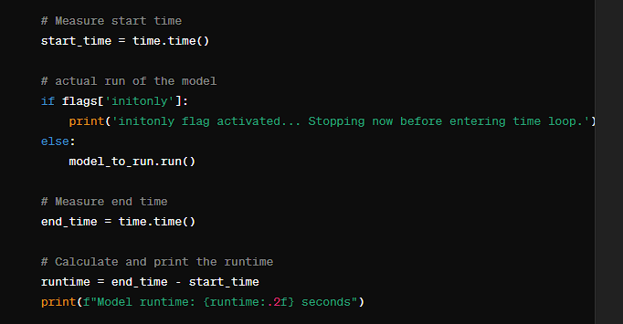
Output
Now we can visualize the model processing time.
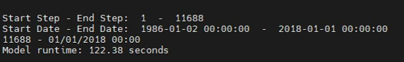
- Change 02 – Enable to use stochastic modelling framework inside LISFLOOD model:
File main.py, add the EnKF and MonteCarlo modelling frameworks to the source code and initialize them as follows.
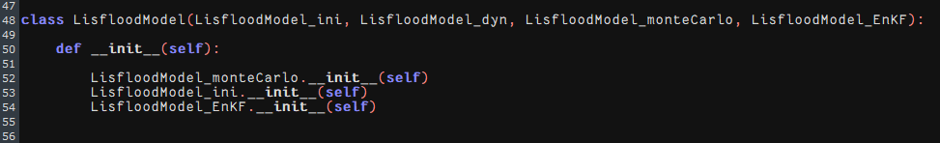

- Change 03 – Enable to use setForkSamples() with the MonteCarlo Simulation
Issue:
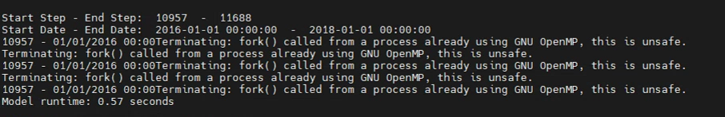
Temporary solution:
- Explicitly turning off the fork() by setForkSamples(False).
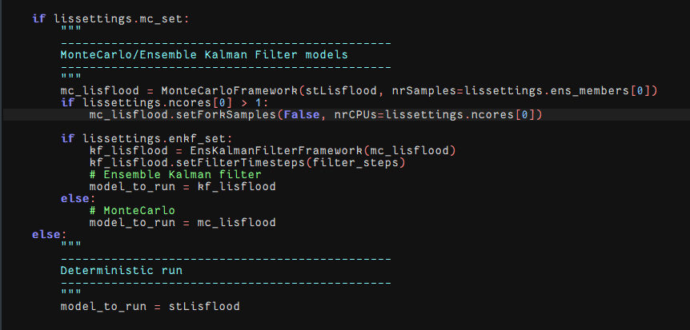
Permanent Solution:
- Open .bashrc file and make following changes.
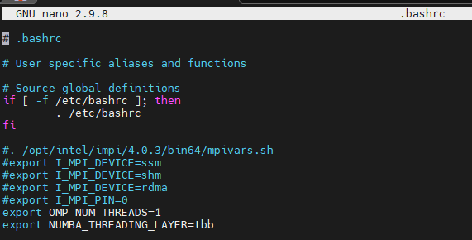
Here,
- Force OpenMP-based libraries to stay single-threaded (OMP_NUM_THREADS=1).
- Let Numba use the TBB threading engine for parallelism.
This combination is often used to avoid conflicts between OpenMP threads and Numba threads when running Python scientific workflows (e.g., LISFLOOD hydrological model, xarray, numpy, PCRaster). It helps keep CPU usage controlled and predictable.
- NUMBA = Python JIT compiler for speeding up code.
- Threading layer = the backend Numba uses for parallel execution.
- tbb = Intel Threading Building Blocks library, a high-performance threading engine.
💡 Why?
- Tells Numba to use TBB for parallel loops instead of other options (like omp or workqueue).
- TBB is generally efficient, stable, and scales well on multi-core systems.
- Without this, Numba may fall back to less efficient thread schedulers.

- Change 04 – Create sub directories with respect to the number of ensemble members:
File Lisflood_dynamic.py , the following code was added.
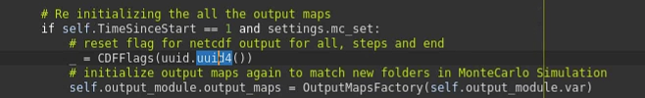

- Change 05 – Enable PCRaster Map outputs:
File output.py script was updated as follows. We have to add the ‘map_path’, ‘map_key’ parameters to the constructor. Then we defined the new file output path if the MonteCarlo option is enabled.
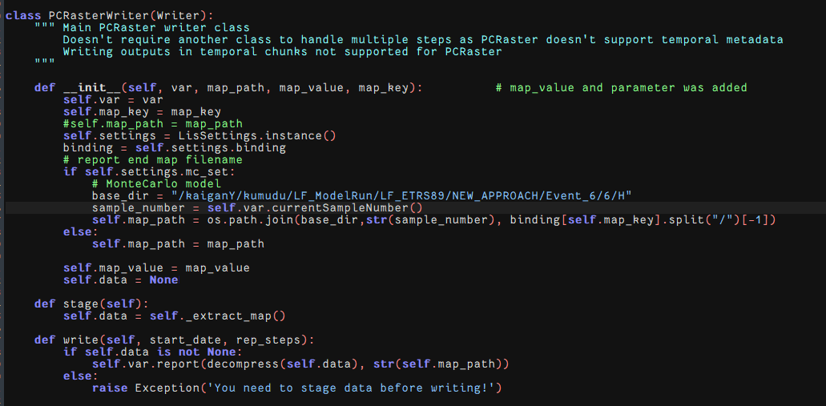
You can use the postmcloop() method only when the “writeNetcdf” and “writenetcdfsteps” options are disabled.
We have to keep in mind that the PCRaster naming conversion can be a problem when we do simulations for longer time periods.

- Change 06 – Add perturbations to different variables by multiplying using uniformly distributed random variables, perturb initial conditions:
File Lisflood_initial.py script was updated as follows.
Here, we use random.seed() to maintain the reproducibility of the results. Then the precipitation data were initially scaled by using a scaling factor of 1.50. The inflow was scaled between 0.75-1.25 (currently no initial conditions or model parameters were perturbated).
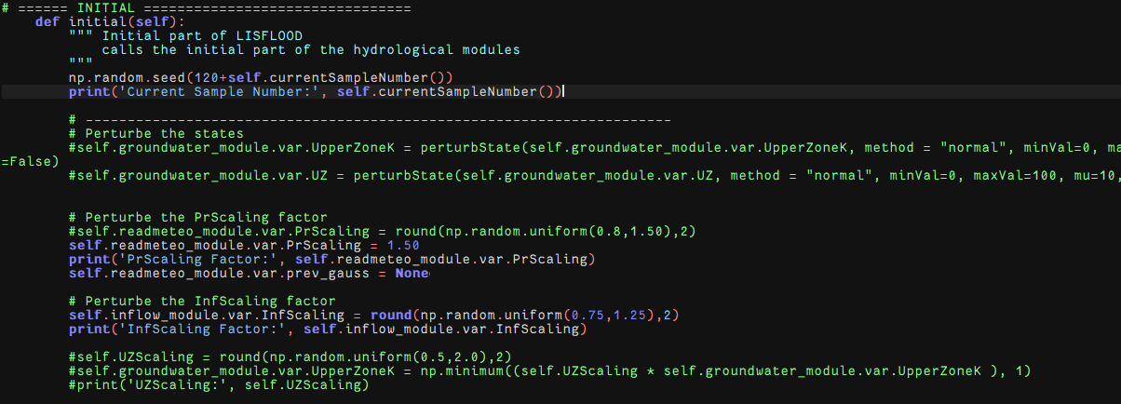

- Change 07 – Perturb precipitation data (Forcing data):
File readmeteo.py, we perturb the rainfall data using spatially and temporally coherent log normal multiplier as below. First, we have to read the correct data layer from the map stack. Since during each assimilation cycle the time step resets to 0.to avoid that we modify the __init__() as follows.

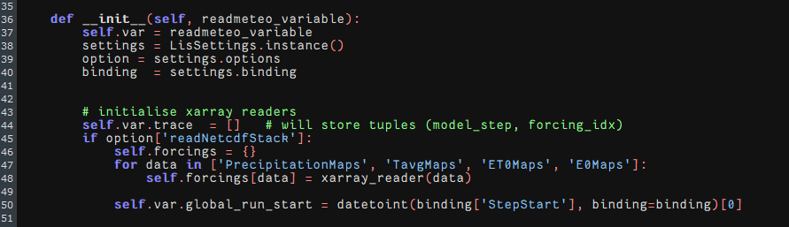

Then we change the dynamic() part as follows.
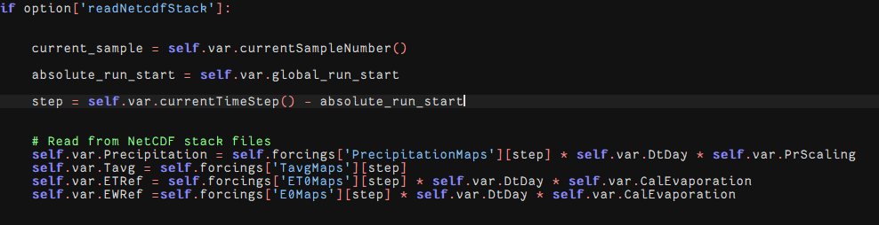
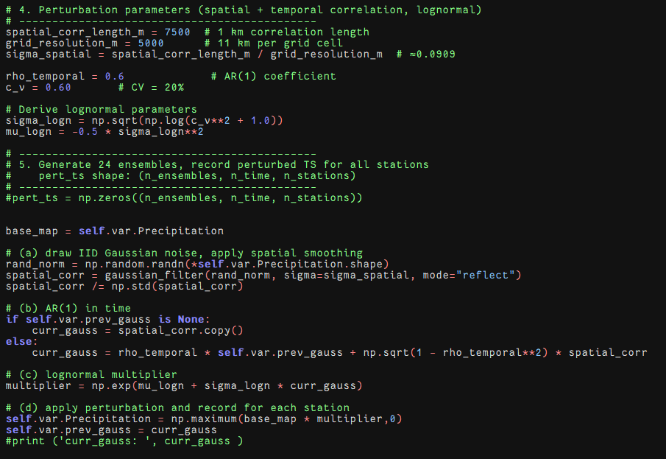
Finally, we perturbed the temperature by adding a gaussian noise.
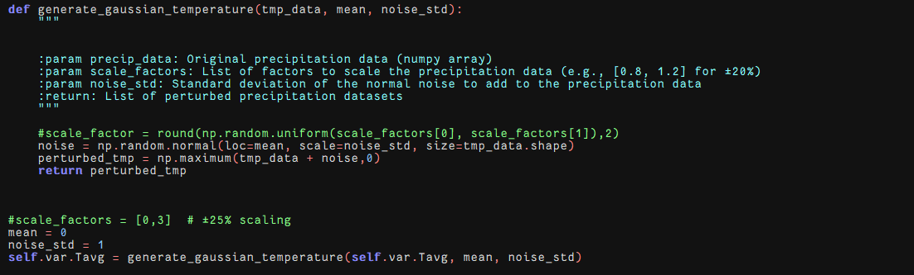
- Change 07 – Perturb inflow data :
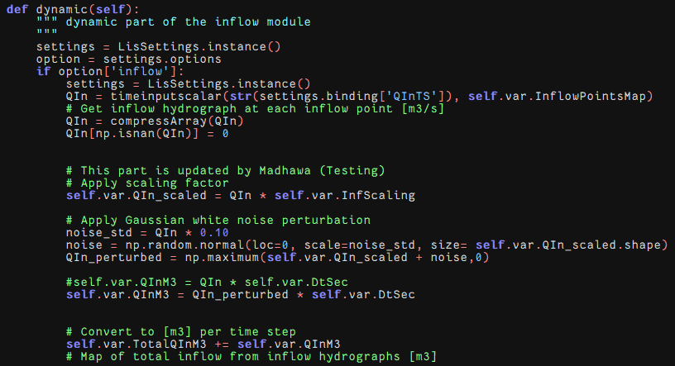

- Change 08 – Develop ensemble Kalman filter (without state augmentation) :
File Lisflood_EnKF.py, here we have created the EnKF script from the beginning to compatible with both single state update and state augmentation.
Following code is about compiling the setState() method for single state variable:
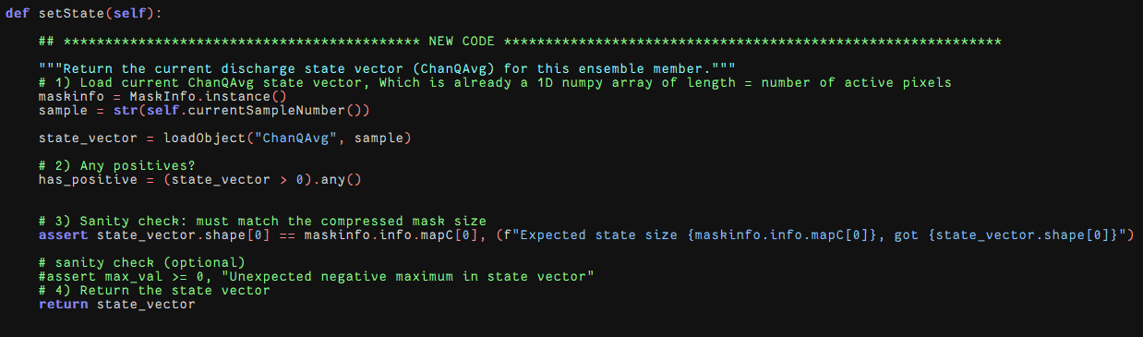

Here we only considered discharge state variable ‘ChanQAvg’.

Following code is about compiling the set Observation() method for single state variable:
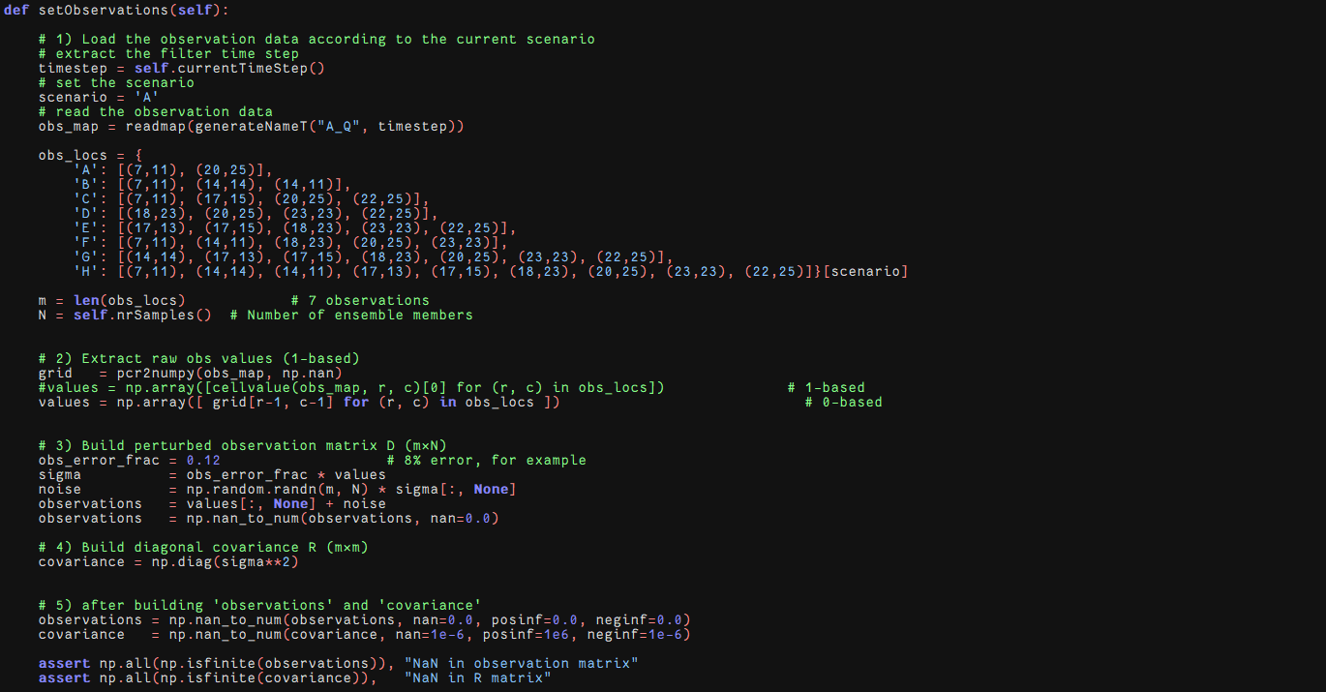
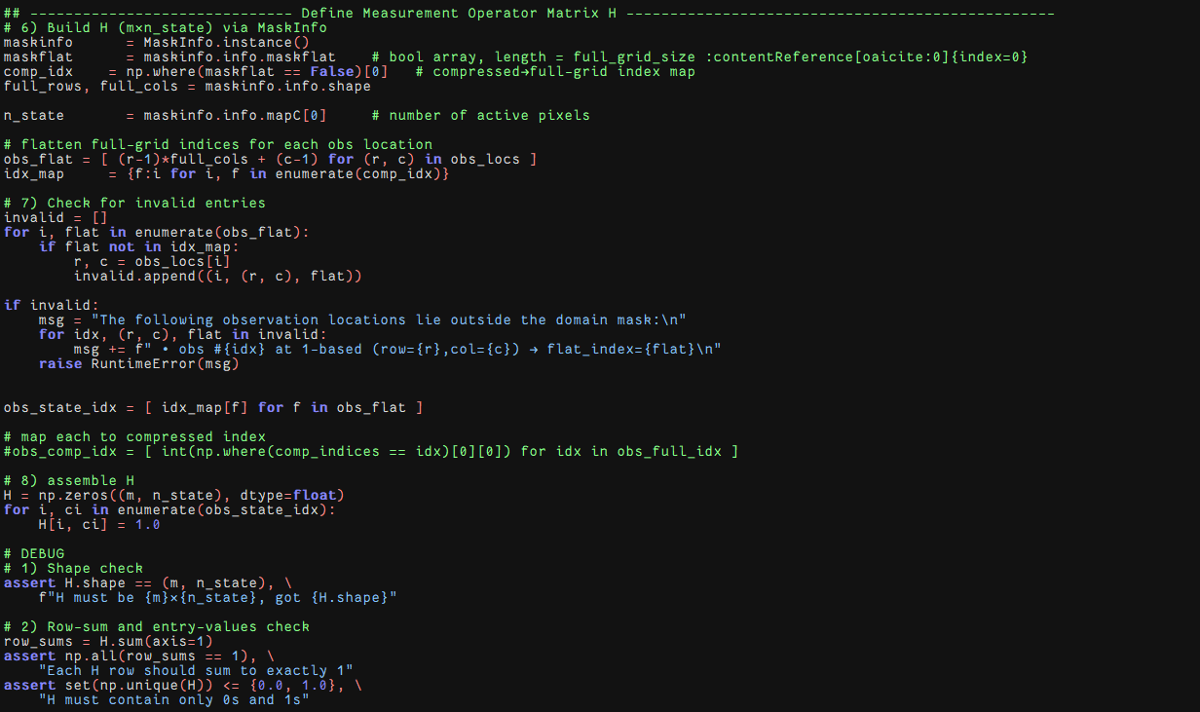
Here the observation operator is compatible with only one state variable.

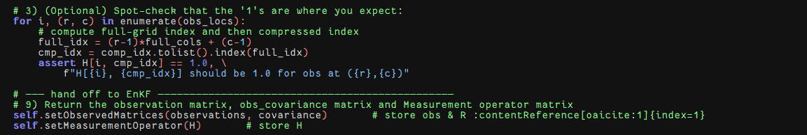

Following code is about compiling the resume() method for assimilation using one single state variable, but updating multiple variables: (Use discharge observations to update the routing variables).
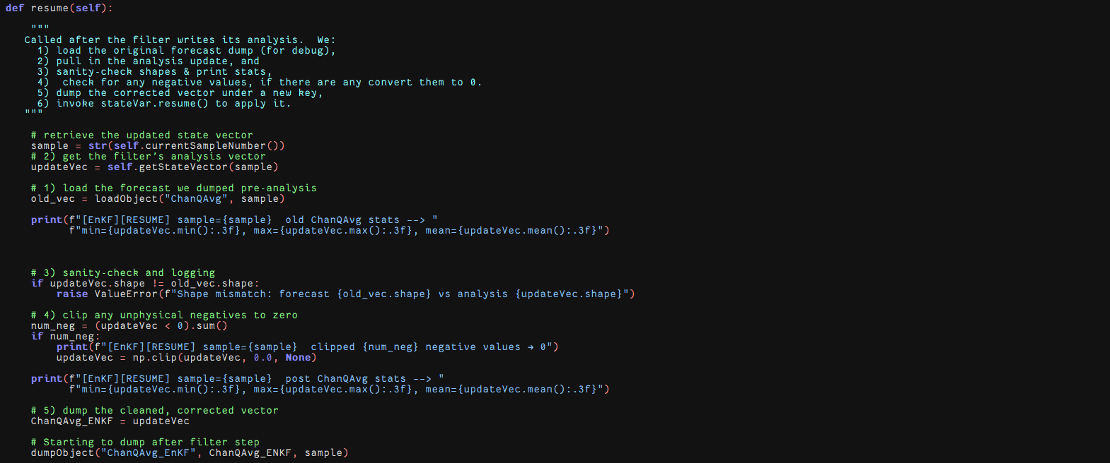
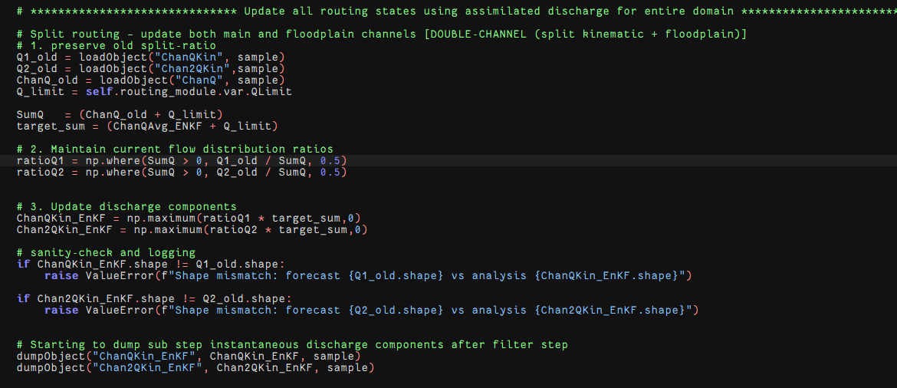

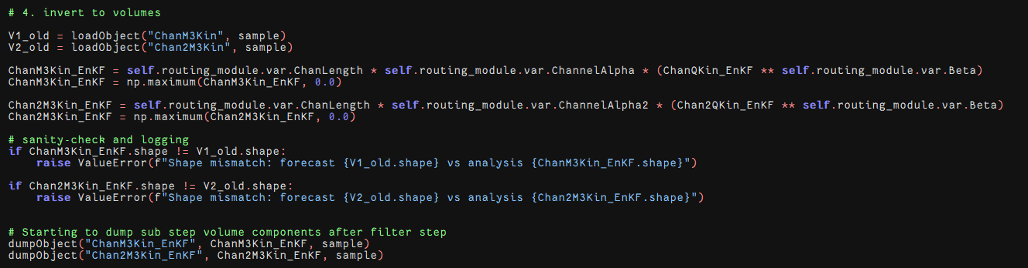
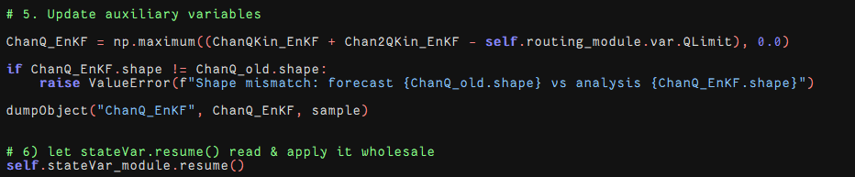

- Change 09 – Develop ensemble Kalman filter (with state augmentation) :
Here we considered discharge state variable ‘ChanQAvg’, soil moisture level 1 (‘W1aR’), soil moisture level 2 (‘W1bR’), soil moisture level 3 (‘W2R’), ground water upper layer (‘UZR’).
setState():

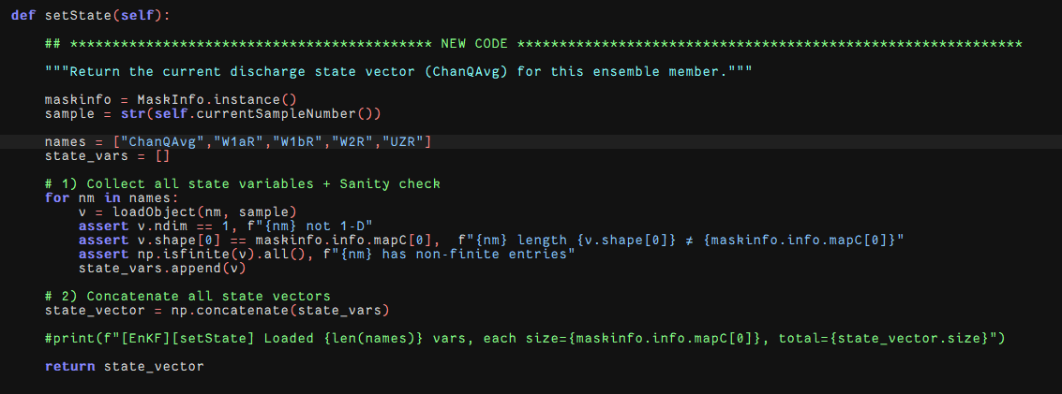

setObservations():
The first part is similar to the above.
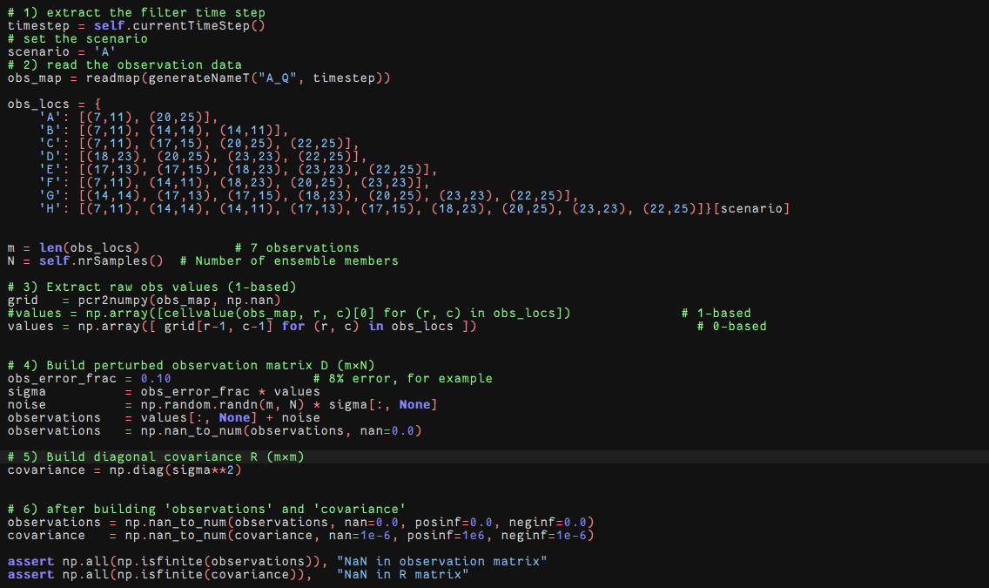
Then the size of the observation operator should be changed with respect to the size of the state variable x.
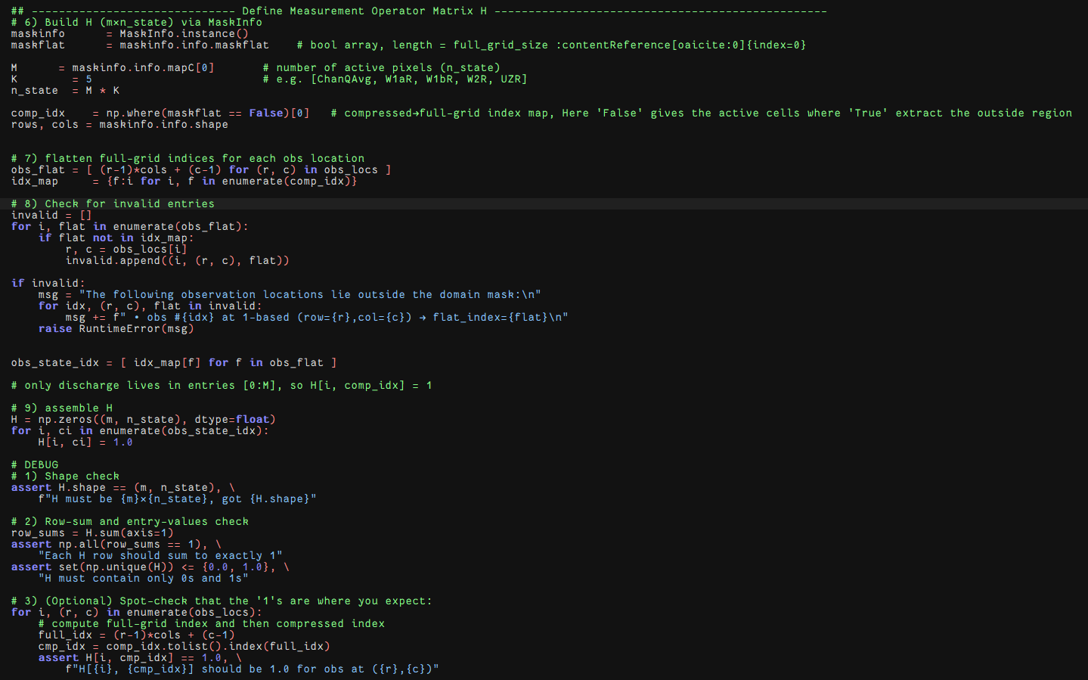
Then in addition to the feature in above case, we update
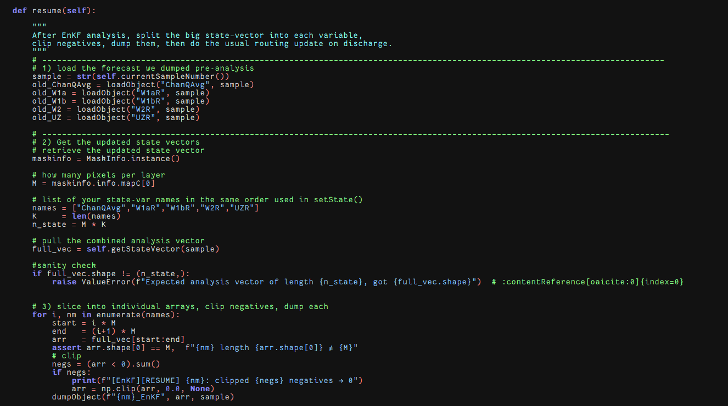
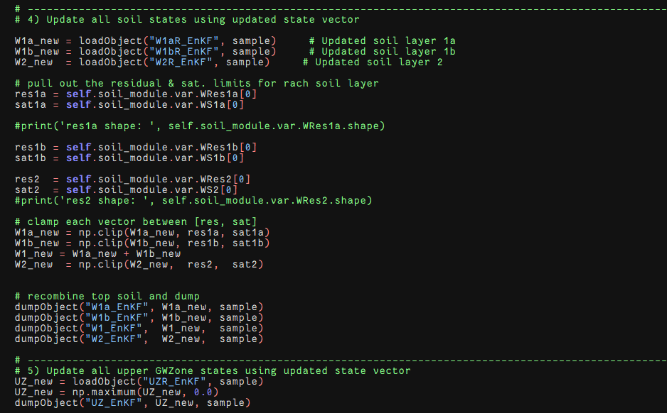
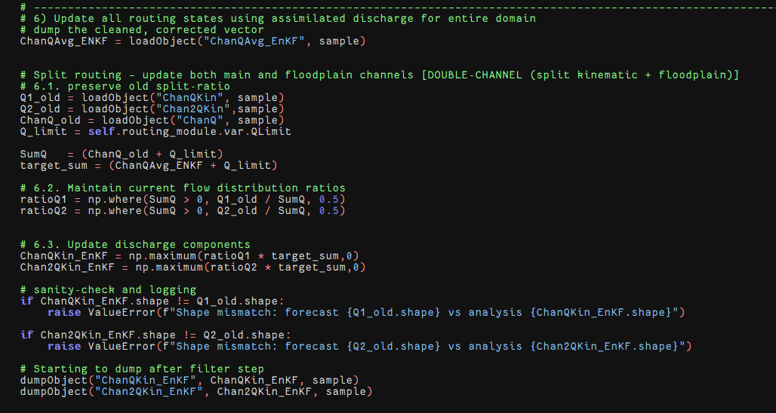
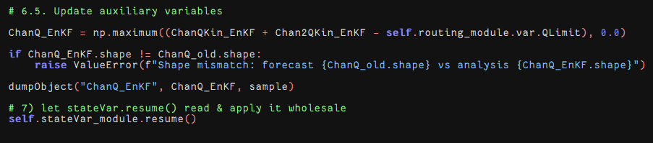

- Change 10 – Update and re-loading the state variables :
Case 1 When updating only channel routing variables.
File stateVar.py, dumping
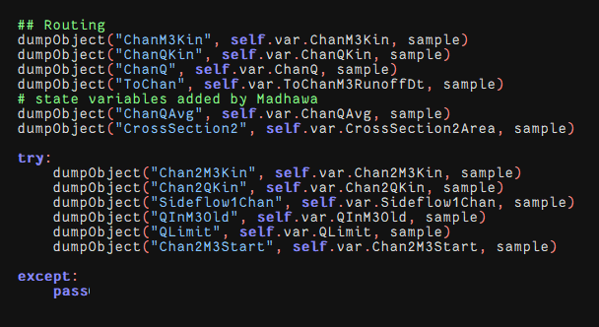
Loading:
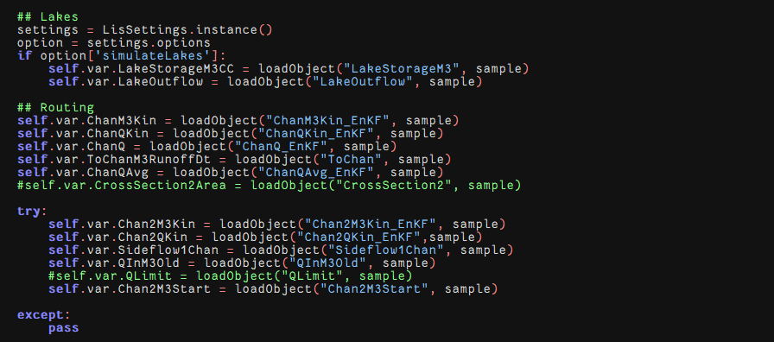
Here the Chan2M3Kin and Chan2QKIn are very important to update. Otherwise the starting point will most likely be 0.

- Change 11 – Update and re-loading the state variables (multi-variable update) :
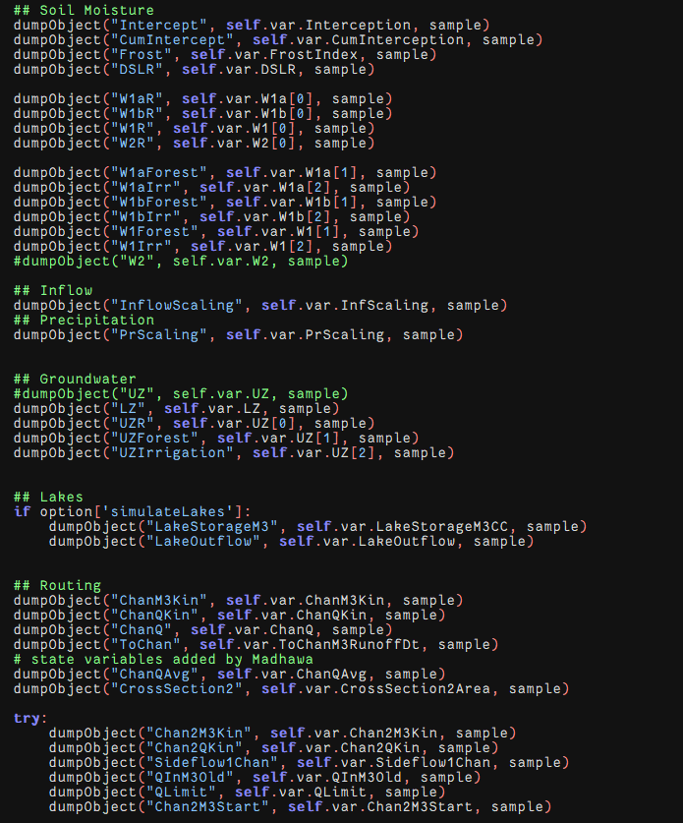
Here, all the forecast state variables were denoted as W1aR, W1bR, W1R, W2R and UZR
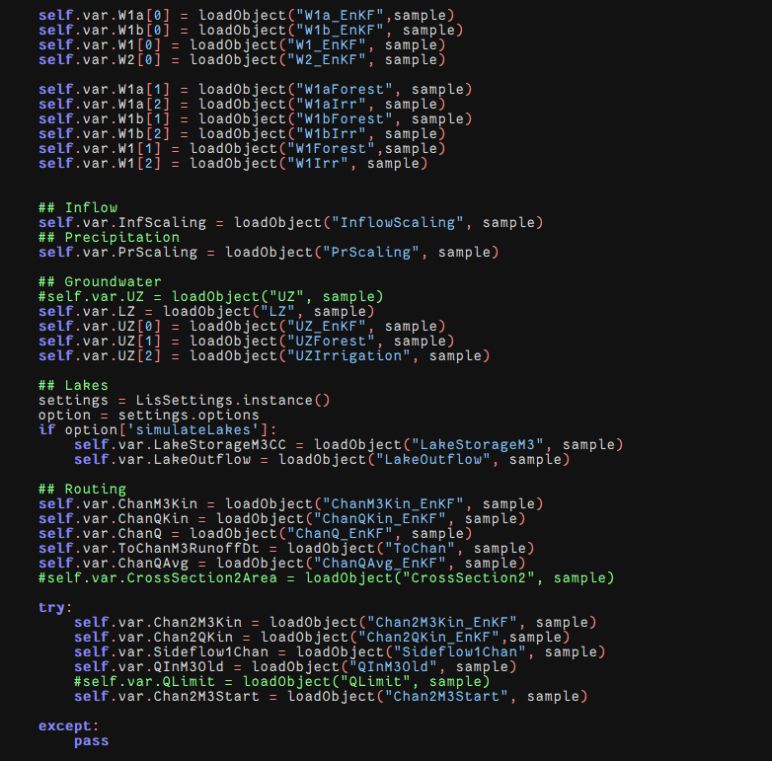
Here all the updated state variables were named by adding ‘EnKF’ to the end of each file name such as W1a_EnKF, W1b_EnKF, W1_EnKF and W2_EnKF and UZ_EnKF etc.

- Future Work
  - Develop Particle Filter Approach
  - Develop an asynchronous EnKF method.
  - Add localization and inflation

